**Object Oriented Programming lab 01**

**Date: 24.01.2024**

**Program 01: Write a Java program to print 'Hello' on screen and your name**

**on a separate line.**

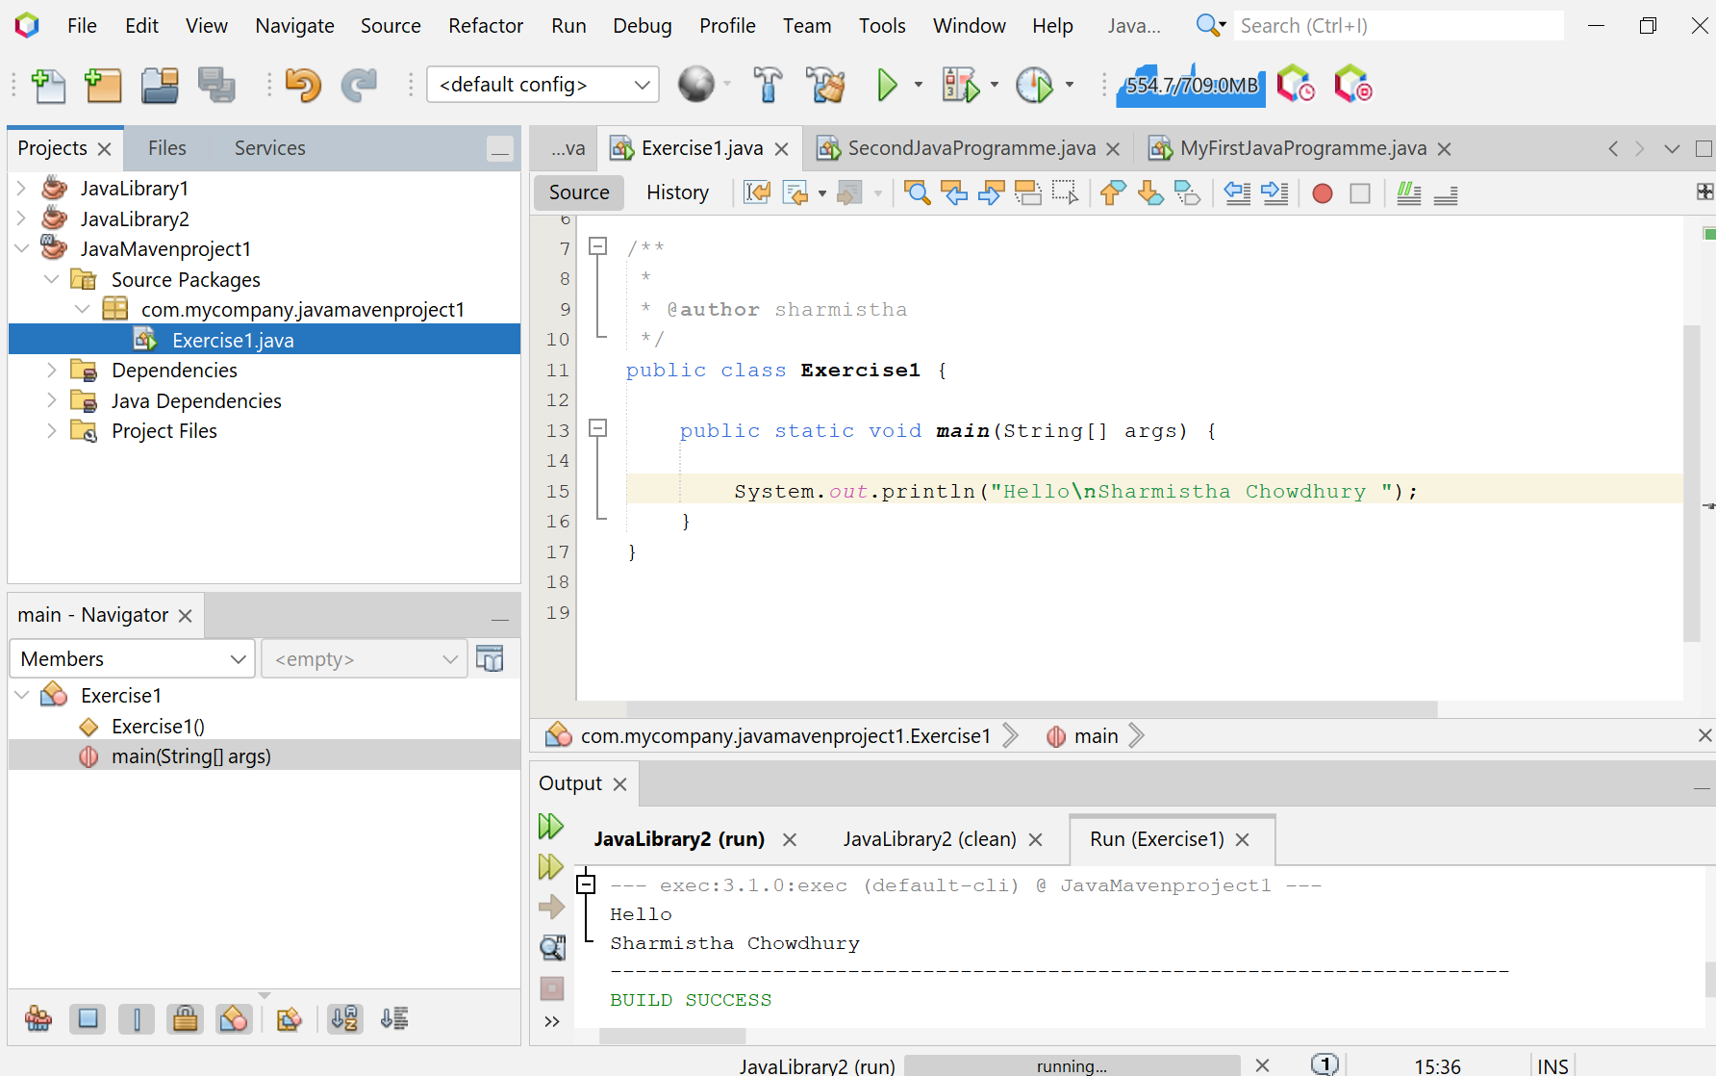

**Program 01: (Alternative Way)** **Using input:**

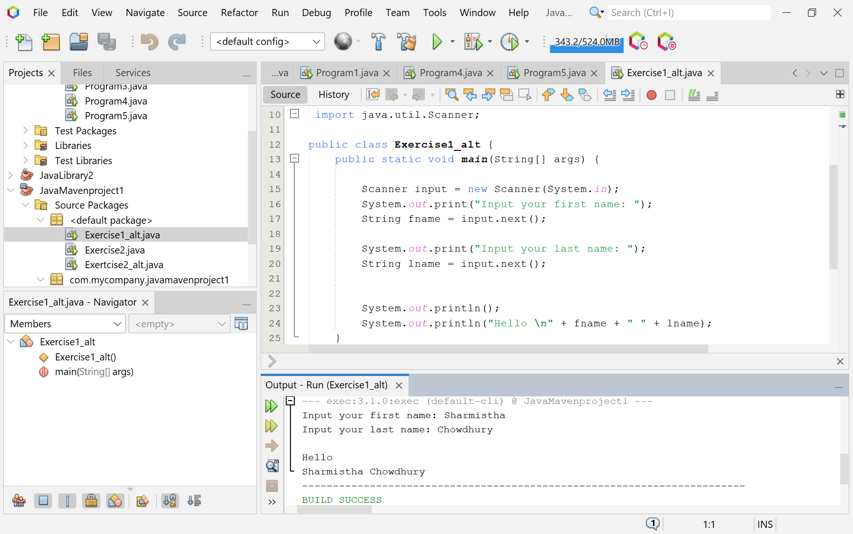

**Program 02: Write a Java program to print the sum of two numbers.**

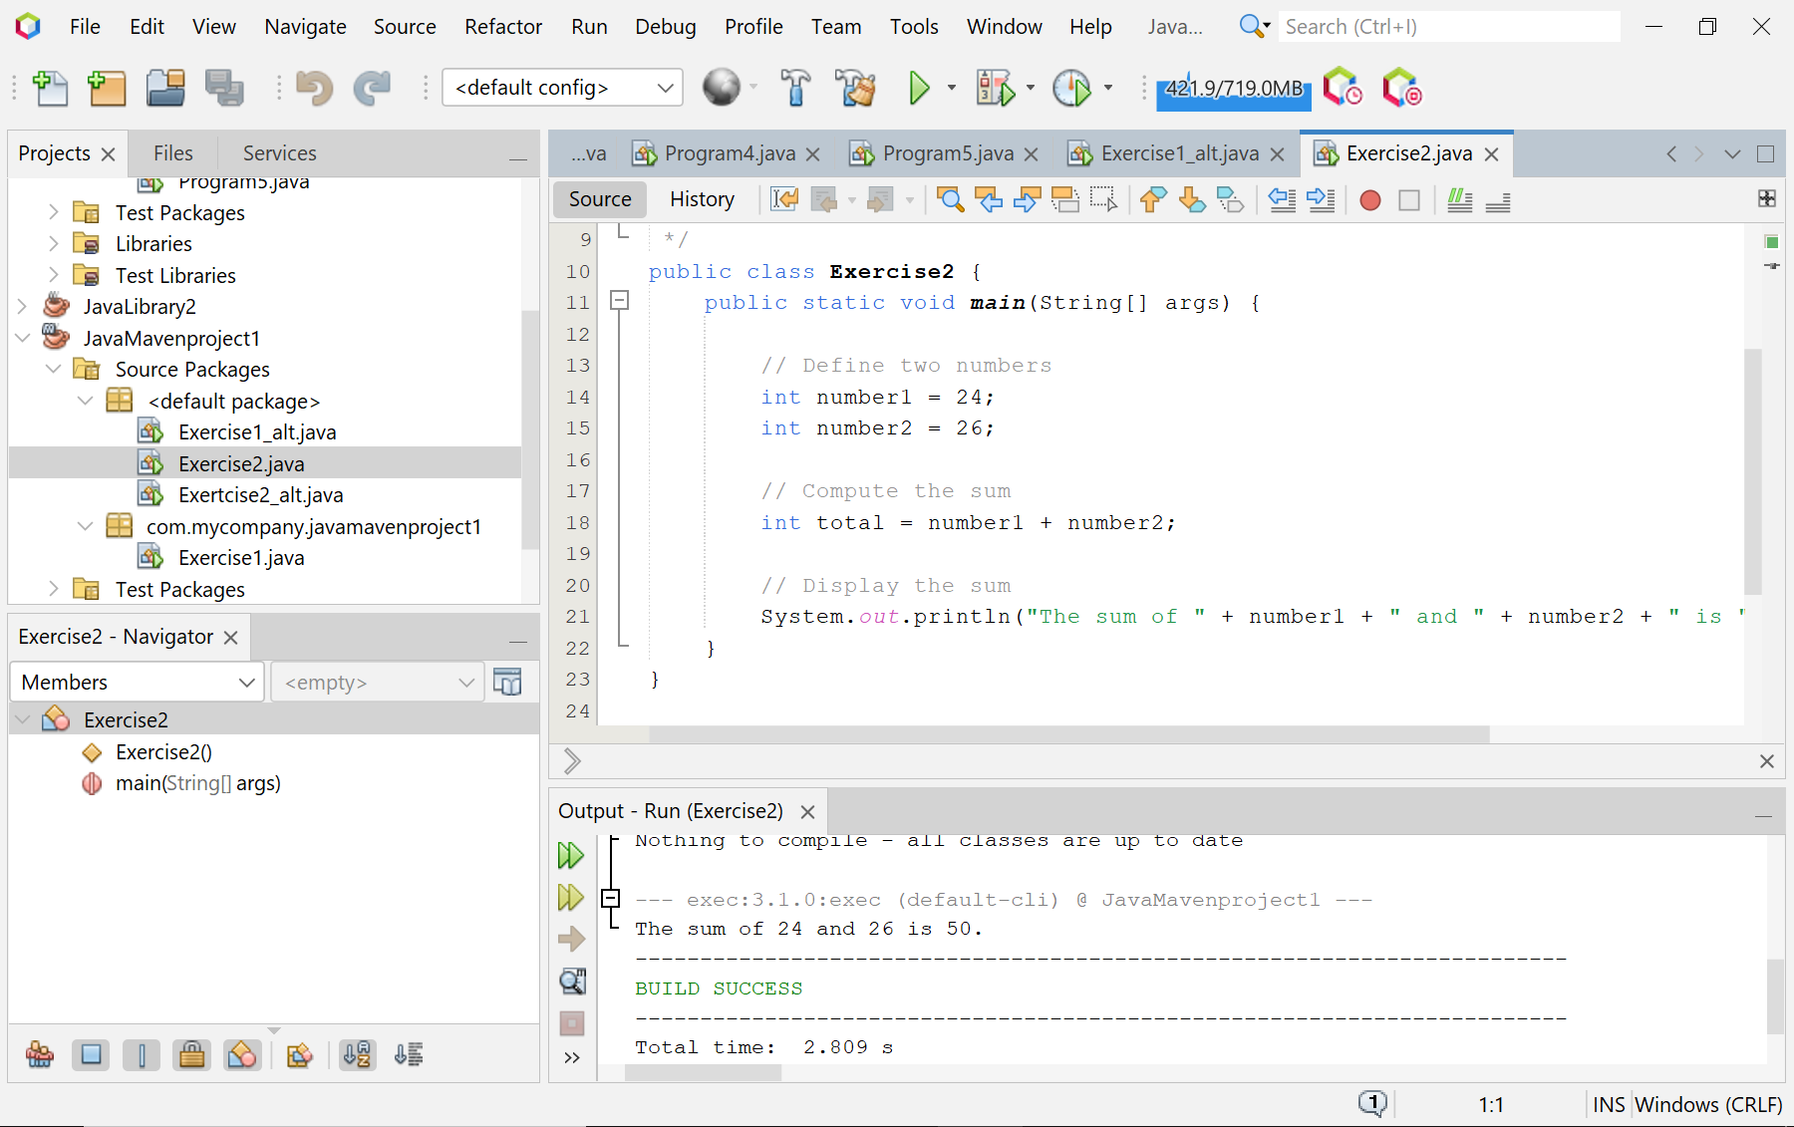

**Program 02: (Alternative Way)** **Using input:**

